SECTION GJ

DUOLINE SHEATHED FUEL INJECTION PIPES.

CHAPTER 1

DESCRIPTION

1. The ’Duoline' sheathed fuel injection pipe assembly provides warning of injection pipe leakage or failure and minimises fire risk in unattended engine rooms and to engines fully enclosed by acoustic cladding, this sheathed pipe assembly also provides a simple but robust one piece unit, which is readily removable when it is required to gain access to the engine and injectors for servicing.
2. The 'Duoline' injection pipe consists of the following:-
3. A high pressure fuel injection pipe (9)(Fig GJ.l), with a pre-formed olive (1) and (25) at the ends, which carries the pressurised fuel oil from the fuel pump to the injector.
4. An outer sheathing pipe (11) of high grade tubular steel, which in the event of failure of the pressurised pipe would carry the leaking fuel to a drain collection tank, via a drain pipe (22) attached to the fuel pump end adaptor drain sleeve, and drain rails from both both engine banks.
5. Sheath locking type end adaptors, one male end and one female end, sealed at the outer side with 'O' seals (8) and (20), are fitted to the ends of the high pressure fuel injection pipe, to ensure that the sheathed outer casing cannot blow out should the high pressure pipe fracture. The fuel pump nut (17) and drain incorporates a rotating drain sleeve (31), for banjo bolt (23) and drain pipe connection, and is sealed with 'O' seals (18) and secured with an external circlip (19).
6. A leakage relief orifice (10) in injector nut (7) will allow fuel from a leaking olive to pass to the area between the nut and high pressure fuel pipe eliminating possible pressure and leakage at nut (7) and 'O' ring (4).

CHAPTER 2

REMOVAL

1. To remove ONE fuel injection pipe proceed as follows:-
2. Release M8 setbolts (15), holding top half clip (16) and base (12) and remove nylon grommet (13).
3. Release and remove banjo bolt (23) together with two dowty seals (24) from the banjo and fuel drain sleeve (31). Release drain pipe (22) from drain rail (27) and remove the drain pipe.
4. Release fuel pump nut (17) from fuel pump (28) and injector nut (7) from the injector inlet port, and withdraw the 'Duoline' pipe assembly from cylinder head cover (5) and fuel pump (28).
5. Blank off the pipe ends with suitable protective caps, or clean polythene sheeting held with binding tape, fit M22 protective caps to the fuel injection pump and injector.
6. Repeat when removing other fuel injection pipes

CHAPTER 3

INSPECTION

1. Examine the outer sheath casing for wear or fretting, paying particular attention to the areas where it is clipped to the air manifold, and at the adaptor nuts. Check injector and fuel pump nuts (7) and (17); these should rotate evenly on the pipe. Examine the threads of all components for serviceability.
2. Examine the condition of nylon grommet (13) and cylinder cover joint (6). Renew if damaged.
3. Examine the surfaces of preformed olives (1) and (25) for indentations liable to cause leakage. The use of high pressure olives which bite into the pipe prevent removal. In the case of olive damage or failure it will be necessary to renew the complete ’Duoline' sheathed injection pipe.

CAUTION DO NOT USE THE FUEL INJECTION PUMP OUTLET PORT, OR THE FUEL INJECTOR INLET PORT, TO FORM AN OLIVE TO THE PIPE AS SUCH AN ACTION WILL DAMAGE THE SEATING IN THESE COMPONENTS AND RENDER THEM UNFIT FOR FURTHER USE.

CHAPTER 4

FITTING

NOTE Fuel injection pipes are only supplied as complete units and should not be bent or interfered with more than necessary to fit to the engine.

1. Remove sealing from the ends of sheathed pipe and flush through to remove any foreign matter.
2. Fit joint (6) and new 'O' ring (4) to injector nut (7).
3. Remove protective caps from the injector and fuel pump ports.
4. Ensure that injector inlet port (3) is central to the opening in cylinder head cover (5) (Section GH), insert injector nut (7) through the opening in the cylinder head cover and screw the nut into the injector. Locate the lower end of the injection pipe with injection pump (28) outlet port and screw nut (17) onto the fuel injector pump outlet port.
5. Fit nylon grommet (13) to sheathed casing (11) and slide into place on the air inlet manifold together with clip base (12), fit top half clip (16), using two M8 setbolts (15) with plain washers (14).
6. Secure injector and fuel pumps nuts (7) and (17) evenly before securing setbolts (15) to avoid possible pipe distortion.

NOTE DO NOT overtighten the pipe nuts. It is only necessary to tighten the nuts one to two thirds of a turn beyond full hand tightness.

1. Using new dowty seals (24) with banjo bolt (23), fit drain pipe assembly (22) to adaptor drain sleeve (31) and drain rail (27) and secure.

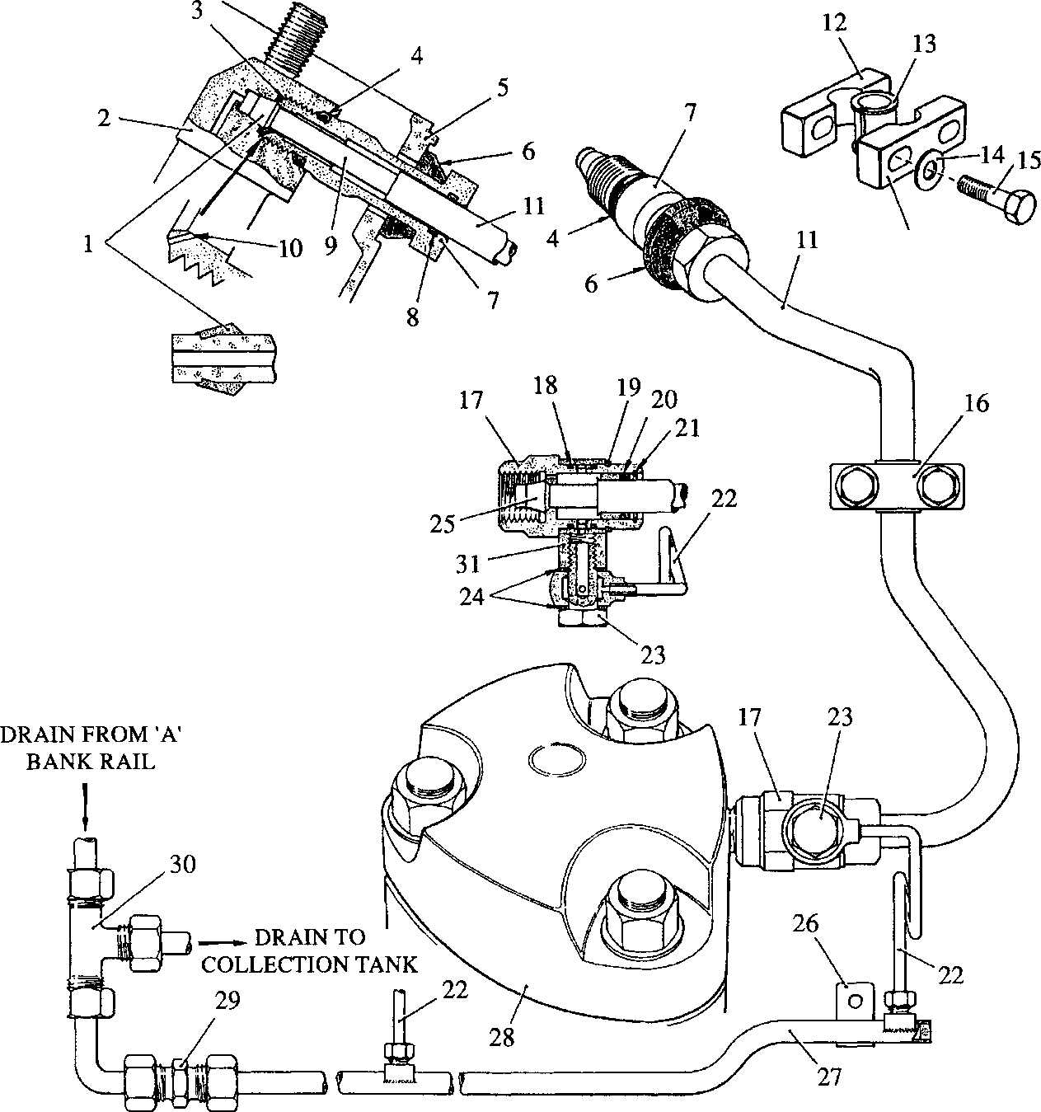

**SPD00495**

**Key to Numbers.**

1. Olive, injector end
2. Fuel injector
3. Injector inlet port
4. 'O' ring
5. Cylinder head cover
6. Joint, cylinder head cover
7. Injector nut
8. 'O’ seal
9. High pressure fuel pipe
10. Leakage relief orifice
11. Sheathing pipe
12. Clip, half base
13. Nylon grommet
14. Plain washer
15. M8 setbolt
16. Clip, half top

Fig GJ.l Assembly sheathed

1. Fuel pump nut
2. 'O' seal, drain sleeve
3. External circlip
4. 'O' seal
5. 'Sealock' bobbin
6. Drain pipe assembly
7. Banjo bolt
8. Dowty seals
9. Olive, pump end
10. Clip
11. Drain rail, 'B' bank
12. Fuel injection pump
13. Straight coupling
14. Equal tee
15. Drain sleeve

fuel injection piping and drain rails.